**Mobilair M480**

**Unrivalled performance for demanding applications**

**The M480 is the most powerful oil-injected portable screw compressor in the Mobilair series, designed specifically for the North American market. With an impressive free air delivery of up to 48 m³/min, it sets new benchmarks in efficiency and versatility.**

At its core lies a high-performance 12-litre Cummins engine delivering 343 kW, fully compliant with stringent Tier 4 emissions standards, ensuring environmentally friendly yet exceptionally powerful operation.

Offering two continuously adjustable pressure ranges (6-8.6 bar and 6-14 bar), the M480 provides maximum flexibility. Its innovative pV control system automatically increases free air delivery when a lower operating pressure is selected, optimising energy efficiency and ensuring air supply is precisely matched to demand.

Versatile and robust, the M480 is ideal for a wide range of applications, from mining and tunnel construction to temporary replacement of industrial compressor stations. It can also be optionally equipped with air treatment systems to deliver cool, condensate-free, or technically oil-free compressed air.

Despite its exceptional power, the M480 is remarkably easy to operate. A single rotary switch starts the machine, while pressure adjustments are made intuitively via a touch display in precise 0.1-bar increments.

The system is available in three configurations: a skid-mounted version, a model with an auxiliary chassis and parking brake, and a road-ready version featuring a heavy-duty chassis with an electric brake. No matter the configuration, a crane lifting eye, forklift pockets, and lashing points ensure safe and secure transportation.

Combining power, efficiency, and ease of use, the M480 is the ideal choice for demanding construction projects across the USA and Canada.

Released for publication, copy requested

Image caption:

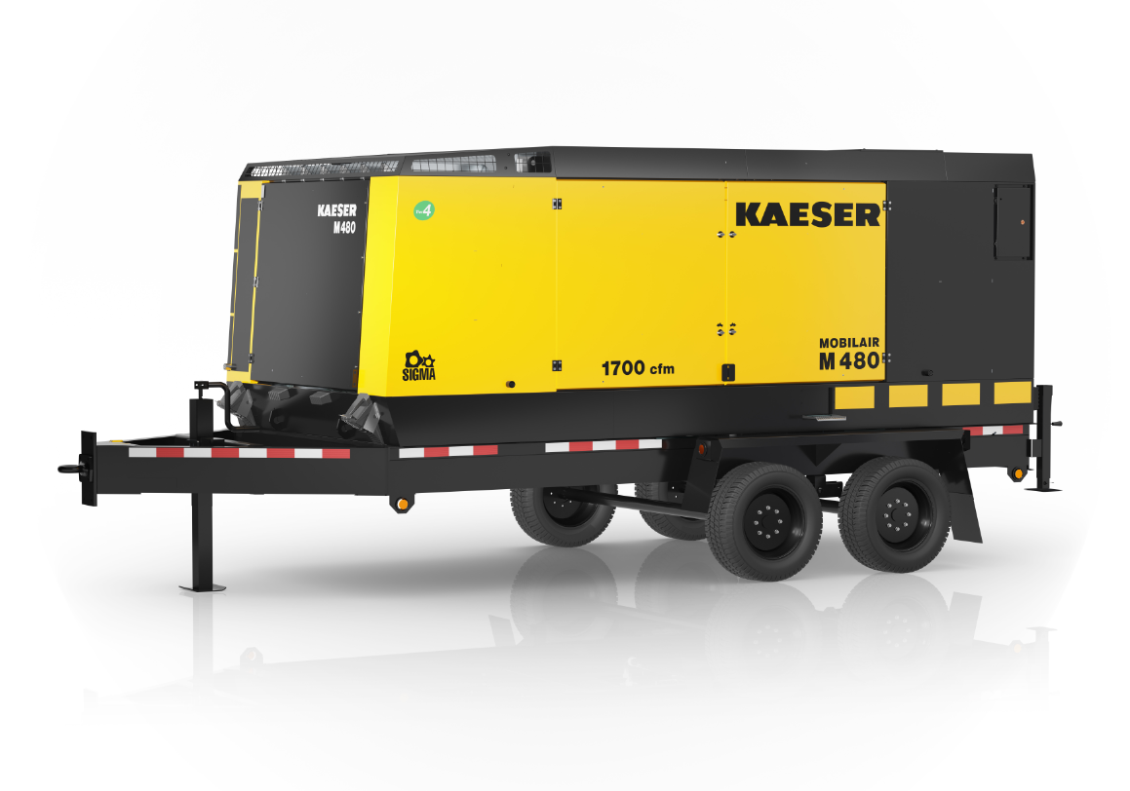

Combining power, efficiency, and ease of use, the M480 is the ideal choice for demanding construction projects across the USA and Canada.