Mobilair M76/M81
Future-forward solutions for demanding construction site conditions
Exciting news in the 7.5 to 8 m³ portable compressor class: one model becomes two. The M76 and M81 portable compressors replace the M82 model and comply with the latest emissions standards - Stage V for the EU and Tier 4 for North America. With these new models, the Mobilair series delivers even greater efficiency, ease of maintenance and user comfort.
At first glance, the two models look identical and share much of the same technology. However, under the enclosure, they feature different powertrains: the M76 is equipped with a Kubota engine, while the M81 is powered by a Hatz engine. Both compressors operate without an SCR system or AdBlue, making exhaust aftertreatment much simpler.
Another key highlight is the flexibility of their compressed air output. Both models offer two continuously adjustable pressure ranges: 6-10.3 bar and 6-14 bar. Thanks to the innovative pV control, air delivery increases at lower operating pressures. This is particularly beneficial for dry ice blasting, as the process is gentler and more time-efficient.
A range of optional compressed air treatment components is also available. For example, compressed air aftercoolers can be integrated for cool, condensate-free compressed air, while microfilter combinations ensure technically oil-free air. The adjustable compressed air discharge temperature, combined with an optional reheating function, provides further advantages for applications such as blasting.
The M76 and M81 can also be configured to provide on-site power. For construction sites requiring electricity, the compressors can be equipped with generators, available in 8.5 kVA and 13 kVA variants. The intelligent control system dynamically distributes power, ensuring that maximum compressor output is available when needed.
Furthermore, both models are designed for maximum ease of use and maintenance. Handling is exceptionally straightforward and includes an automatic shutdown function as standard. Last, but not least, a new spin-on cartridge for oil separation simplifies servicing, making filter changes quicker while reducing waste.
Depending on the configuration, 1500 kg or 1800 kg chassis variants are available, whilst a skid-mounted version is also offered for added flexibility.

Released for publication, copy requested

Image caption:
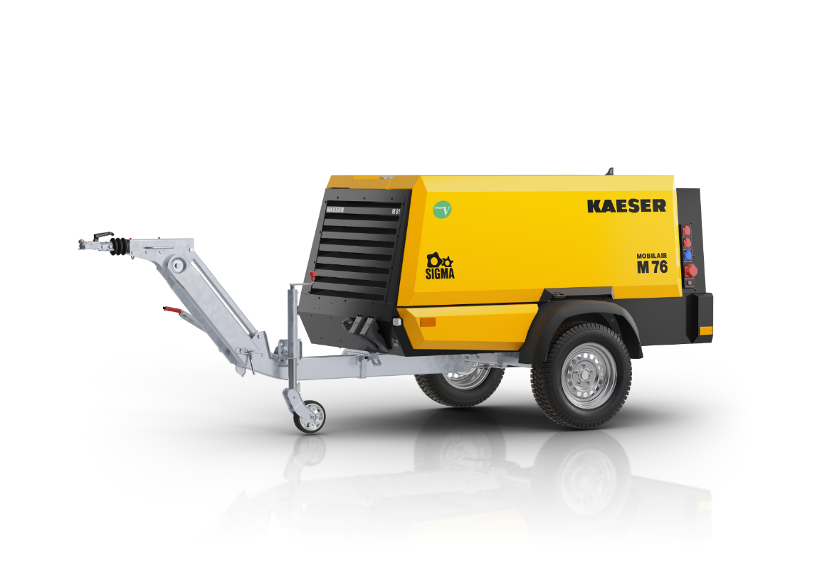
The perfect choice for global applications: M76 with Kubota engine or M81 with Hatz engine.

