Kaeser at IFAT
Efficiency in motion
Kaeser Kompressoren unveils the world premiere of its brand-new turbo technology, alongside a suite of sustainable solutions for the future of compressed air. At IFAT, Kaeser will showcase forward-thinking solutions for water management, sustainable sewer rehabilitation, and more.
With increasing demand for energy efficiency and resource conservation, a cost-effective and reliable compressed air supply is critical to wastewater treatment in both municipal and industrial facilities.
Without giving too much away, new possibilities are opening up in the low-pressure technology sector. The latest innovation in the turbo range - on display as a prototype - is set to define new standards in efficiency and sustainability. With an impressive delivery volume of up to 270 m³/min, this turbo blower, developed in-house by Kaeser, combines exceptional performance with minimal energy consumption and a remarkably compact footprint.
The FBS rotary screw blower from Kaeser represents the next milestone in the development of oil-free compression blower technology, designed especially with water industry applications in mind. With a flow rate of 18 to 72 m³/min and pressure differentials from 0.3 to 1.1 bar, as well as a selection of motors ranging from 45 to 110 kW, the innovative FBS is setting new standards in terms of energy efficiency, space-saving design and automation. Thanks to the integrated compressor control Sigma Control, efficiency and operational reliability are at a whole new level and operation is easier than ever before. Using the specially developed Kaeser app, even from anywhere.
The 15-bar version of the M17 portable compressor, with a delivery volume of 1 m³/min, is the ideal choice for trenchless fibre-optic cable installation. The latest models feature numerous refinements and additional options designed to deliver even greater user benefits. For the first time, both the M13 and M17 are available with an integrated compressed air aftercooler. In addition, the mobile M27 PE shines with a neu generator version that allows compressed air and 6,5 kVA of electricity simultaneously.
All this and more will be on show at IFAT in Hall B2, Stand 351, alongside other efficient compressed air systems and sustainable technologies for tomorrow’s compressed air supply. Highlights include a brand-new design package for efficient blower station planning, highly efficient rotary screw blowers, robust rotary lobe blowers, zero-emission portable compressors, and the Sigma Air Manager 4.0 cross-machine compressed air management system.
Released for publication, copy requested

Image caption:
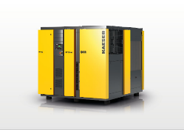
The space-saving and efficient powerhouse for the low-pressure range: Kaeser's new turbo blower prototype.
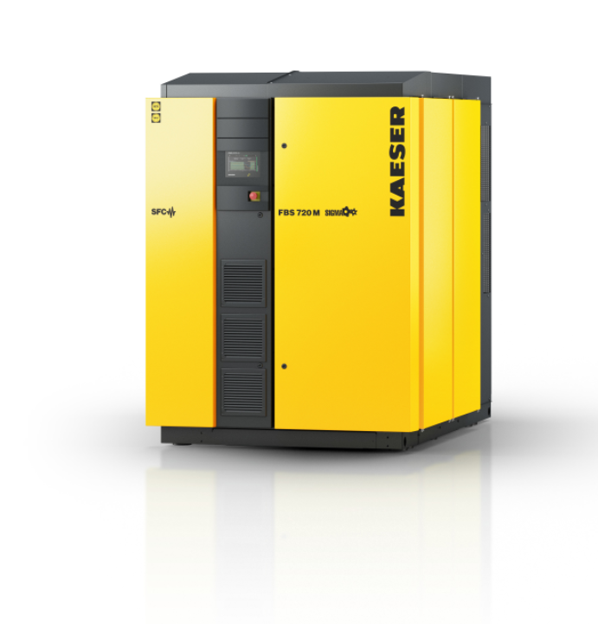
FBS series rotary screw blowers are true standouts on account of their high levels of efficiency and compact design.

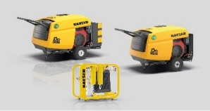
The M13 and M17 portable compressors are now available with either integrated or external aftercoolers.
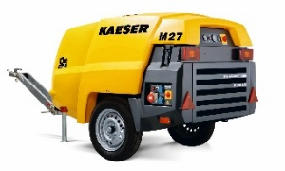
The Mobilair 27 not only delivers impressive performance, but is also available with a wide range of equipment options to ensure maximum flexibility.

