M13 and M17

Compact powerhouses

Light, powerful, quiet, versatile and easy to transport – compact machines from the Mobilair M13 and M17 series have always had plenty to offer. When it comes to the latest versions, a wide range of detail enhancements and additional equipment provide even more benefits than ever before. Moreover, for the first time, the M13 and M17 are now also available with an integrated compressed air aftercooler.

With a compressed air delivery volume of 1.2 m³ per minute at 7 bar, the M13 portable compressor is the perfect partner for operating air hammers, pneumatic drills, saws, grinders and wrenches, not to mention impact moles and sewer robots. 10- and 13-bar versions of this compact powerhouse are also available. Meanwhile, the 15-bar version of the M17, with a delivery volume of 1 m³/min, is the ideal choice when it comes to trenchless fibre-optic cable laying.

Both of these rotary screw compressors are driven by an air-cooled, 4-cylinder Honda petrol engine via a low-maintenance V-belt drive. A generously sized 20-litre fuel tank ensures sufficient fuel for long daily work shifts.

Maintenance too is child’s play. The oil separator tank, which serves to ensure a low residual oil content for the compressed air, is equipped with spin-on cartridges, making cartridge changes quick and easy.

For added sound protection, all models are equipped with a corrosion-resistant sound enclosure constructed from roto-moulded polyethylene (PE).

For applications in enclosed spaces, on construction sites or in workshops, an emissions-free E-version featuring a 3-phase electric motor is available.

Even very small loading areas can accommodate these compact compressors: they can easily fit inside a closed van, on the loading bed of an HGV or in a pick-up, leaving the trailer coupling free for other transport purposes.

Where specific applications require cool and condensate-free – or even technically oil-free – compressed air, the M13 and M17 can additionally be equipped with an external or an integrated compressed air aftercooler, optionally available with a microfilter combination. Installed on a support frame, the external aftercooler features fixed connection lines for compressed air, condensate return and the necessary electrical supply (12 V, provided by the compressor) to power the aftercooler fan.

When the integrated compressed air aftercooler is fitted, the aftercooler fan can be switched off, allowing the operator to select between uncooled or cooled (and therefore also condensate-free) compressed air. On these versions, which are 12 cm longer and 13 kg heavier, maximum pressure can be reduced to 7 bar. This enables, for example, the M17 to be used both for cable blowing at 15 bar and for preparatory work with impact moles at 7 bar.

On all versions, the accumulating condensate is evaporated by the hot exhaust gases from the engine, or in the case of electric versions, collected in a designated canister.

When it comes to manoeuvrability, the M13 and M17 are exceptionally user-friendly. A long push bar, wheels fitted with pneumatic tyres, four convenient hand grips and a retractable lifting eye guarantee simple transportation to the construction site.
Free for publication, copy appreciated
Image:

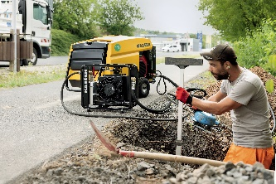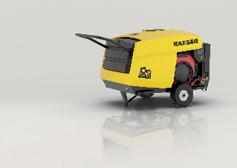

Small but powerful: the M13 and M17 provide compressed air for a multitude of possible applications.

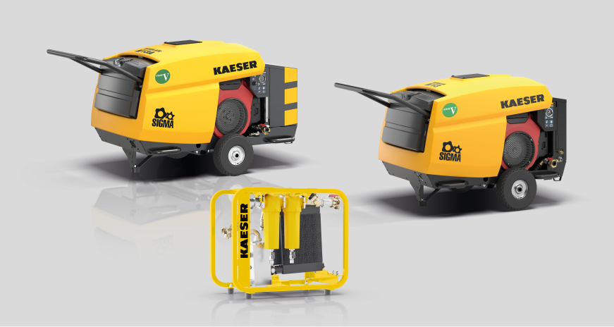

The portable compressor can be equipped with either an integrated or an external compressed air aftercooler.

