New turbo blower
Redefining the state of the art
Kaeser Kompressoren gives a fascinating insight into the user-oriented development of a new turbo blower. Following milestones such as the Compact rotary lobe blower and rotary screw blower, Kaeser is once again setting a new benchmark in blower engineering for low-pressure applications. The machine is currently a fully functional system, expected to reach the market in its present form in 2027.
The innovative design of the new turbo blower promises not only significantly lower operating and maintenance costs, but also effortless integration into existing installations, thanks to its minimal footprint and flexible connection options.
Key advantages of the next-generation turbo blower:
- Significant efficiency gains: Efficiency has been significantly improved in the 300 kW power range.
- Maximum dependability: The magnetic bearing drive system enables wear-free operation and virtually unlimited restart capability, with built-in protection against power supply failures. The variable-speed direct drive eliminates the need for gear transmissions and complex inlet and outlet guide vanes.
- Compact powerhouse: With approximately 300 kW of drive power on a footprint of just 5 m², the machine is exceptionally compact. It achieves a peak flow rate of more than 16,000 m³/h (approx. 267 m³/min). Components such as the intake filter, diffuser and compensator are integrated and factory-assembled as standard.
- Adaptability: Flexible positioning of the air and power connections allows for seamless integration into existing installations.
- Smart und resilient: The Sigma Control 3 blower controller uses state-of-the-art technology to maximize efficiency and meet the highest digital security standards. It also enables optional remote monitoring, allowing operators to mirror machine data directly to their smartphones via the Kaeser web app.
With this new turbo blower, Kaeser reaffirms its position as an innovation leader and offers a compelling preview of the next generation of efficient, compact low-pressure turbo blowers - complete with digital services - due to become available in 2027.
Free for publication, Copy appreciated

Images:
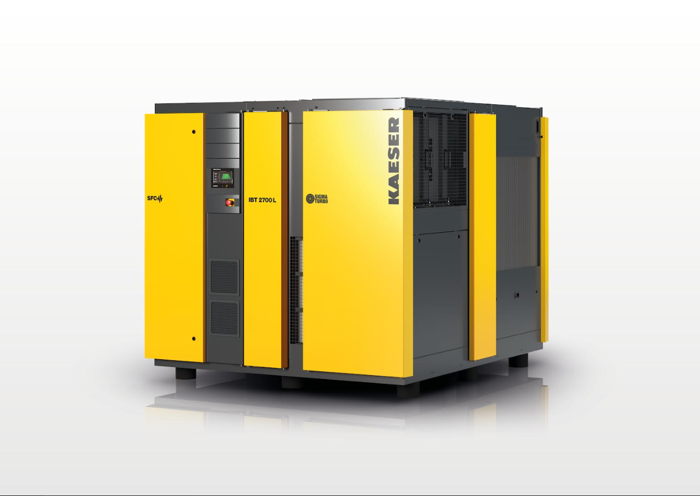
Kaeser’s latest cutting-edge turbo blower: efficient, reliable, and compact.

