Thomas Kaeser turns 70
A life led with passion and wisdom
“My brother is my role model, because he is always level-headed, remains calm, and does not see ‘problems’, just ‘challenges’ to which there is always a solution”. This sentence, written by one of his sisters many years ago in a school essay, neatly sums up Thomas Kaeser’s approach to life. On the 14th of August, he celebrates his 70th birthday. Born the third of seven children, amongst his siblings he learned early on how to negotiate and find solutions: “There were always seven different opinions and seven different perspectives, all of which had to be coordinated in a target-driven manner,” he remembers fondly of his childhood and youth. “That was good training in how to run a company.”
Family comes first
Then as now, family holds a special place in his heart. Not only his immediate family, but also the corporate family at Kaeser Kompressoren, which successfully grew ever larger as the years passed and the company expanded across the globe. Today, Kaeser provides jobs for over 7500 employees and is represented in more than 140 countries by a comprehensive network of over 50 subsidiaries and about 70 exclusive distribution partners. Despite this global growth, Thomas Kaeser has always remained true to his hometown of Coburg as the main production facility, as well as to his convictions: “It is important to stress that we are a family business,” he always emphasises, demonstrating his continued commitment to his family.
A great economic thinker and leader
This approach applies not only to his own company, but further afield as well – much further afield in fact. In July 2023, he was presented with the Bavarian Order of Merit by Dr. Markus Söder, Minister-President of Bavaria, who described him as a “great economic thinker” and a “sustainable voice for the Upper Franconian economy”, whom he personally holds in high esteem and who “always has excellent ideas”.
This wealth of ideas also characterises Kaeser Kompressoren: the company has always been associated with technical innovation and market leadership throughout its 100-year history, and has grown continuously since the day it was founded. The objective of this compressed air systems provider is to offer efficient, economical, reliable and sustainable solutions that support businesses across the globe in making their production processes ever more safe and efficient, thereby enabling their growth, creating new job opportunities and driving prosperity.
Ever more efficient
Thomas Kaeser’s life journey has also been marked by efficiency. After completing his grammar school education at the Coburger Gymnasium Ernestinum, he went on to study a Master of Business Engineering at the Karlsruhe Institute of Technology, followed by trainee positions in France and the USA, and finally a diploma in Business Engineering. Having joined his parents’ company in 1979, in 1985 he became a managing partner and in 2012, Chairman of the Managing Board. He runs the company together with his wife, Tina-Maria Vlantoussi-Kaeser. The couple have two children, Alexander-Jan and Philipp.
In addition to his role as Chairman of the Management Board at Kaeser Kompressoren SE, Thomas Kaeser is also Member of the Board of vbm and bayme (Associations of the metal working and electrical industries in Bavaria) for Bavaria and Chairman of the Management Board of VMET (Association of metal and electric working industries in Thuringia). He chairs the vbw (Association of the Bavarian industry) district group of Upper Franconia as well as the Western Region of the vbm. In addition, he is involved in the Board of the VDMA (Mechanical Engineering Industry Association), the Exhibitor and Trade Fair Advisory Board of the Hannover Messe, and the Exhibition and Trade Fair Committee of the German Economy (AUMA), as well as the PNEUROP Council, the European association of compressor manufacturers. In November 2012, he was awarded the State Medal for Excellent Services to the Bavarian Economy.
Does this hectic schedule leave any time for leisure? Actually, yes – for classical music and jazz, not to mention regular exercise in order to stay fit and healthy. For his 70th birthday, Thomas Kaeser will be taking a few days’ holiday in Greece – the country from which his wife, Tina-Maria Vlantoussi-Kaeser, originates. Whilst there, perhaps he will look back at the many challenges he has faced, and continues to face, in his life. Just as with the challenges of the past, he will resolve those of the present and the future with the level-headedness and calm for which he is renowned, and thereby become a role model for many more.
Images:

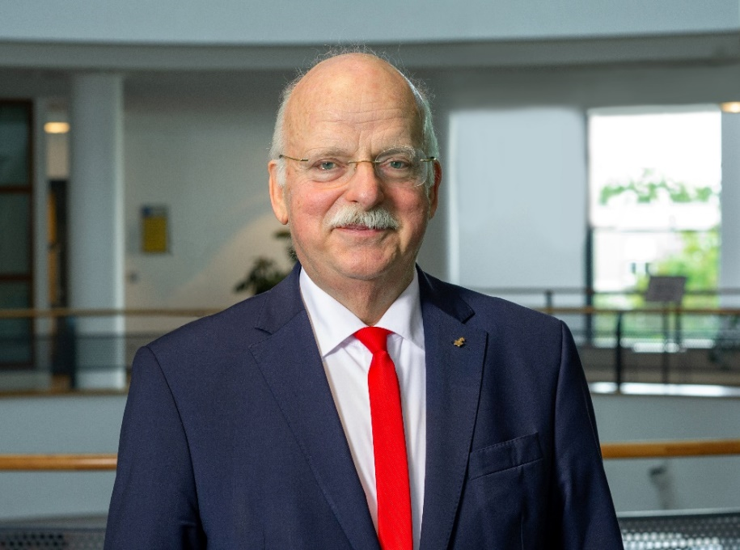
Thomas Kaeser, Chairman of the Managing Board at Kaeser Kompressoren, is celebrating his 70th birthday.

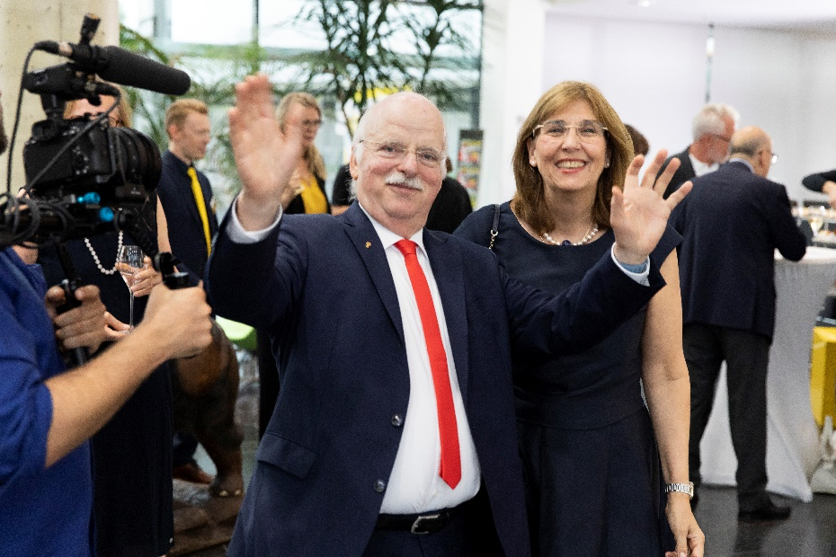
An outstanding team over many decades: Thomas Kaeser with his wife and fellow board member, Tina-Maria Vlanoussi-Kaeser.

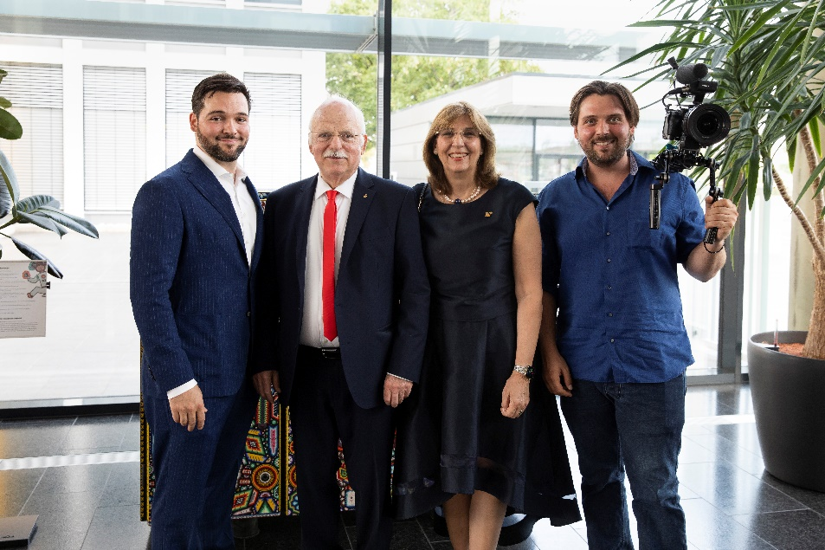
For Thomas Kaeser, family is paramount. Image (from left to right): Alexander-Jan Kaeser, Thomas Kaeser, Tina-Maria Vlantoussi-Kaeser, Philipp Kaeser.

