Kaeser Kompressoren at SEMICON in Munich
Secure processes, minimal TCO: Compressed air for the chip industry
Securing process stability and sustainably reducing the Total Cost of Ownership (TCO) are key success factors in the semiconductor industry. Since the continuous provision of compressed air in accordance with Class 0 purity standards requires significant amounts of energy, efficient generation delivers an immediate and tangible reduction in operating costs. This applies both to high-end logic chip manufacturing and power semiconductor production.
Sigma Air Manager 4.0: Optimum efficiency

Adaptive, efficient and networked: the Sigma Air Manager 4.0 compressed air management system enables especially efficient operation of compressed air or blower stations. Its integrated Energy Management Software (EMS) ensures energy-saving operation of multiple compressors, dryers or filters. Thanks to networking of all components within the compressed air station via this intelligent master controller and the secure Kaeser Sigma Network, comprehensive monitoring, energy management and predictive maintenance work are all possible. This minimises downtime and maximises productivity.

CSG series: A class above in performance and efficiency
When it comes to energy efficiency, CSG series oil-free compression rotary screw compressors take the production processes to the next level. Specially developed for the sensitive requirements of the semiconductor industry, these systems deliver compressed air to residual oil content Class 0 in accordance with ISO 8573-1, ensuring maximum product safety for wafer manufacturing, lithography, and pneumatic handling in cleanrooms. What’s more, thanks to IE5 synchronous reluctance motors and the Sigma Profil, CSG compressors achieve significant energy savings. The water-cooled option with i.HOC dryer and heat recovery uses the compressor exhaust heat twice – achieving maximum cost efficiency and process reliability.

Heat-regenerated desiccant dryers Calosec

Kaeser’s Calosec series of heat-regenerated desiccant dryers stands out with its versatile system design, providing the most cost-efficient solution for any requirement. They provide the perfect building block for compressed air networks that require extremely low pressure dew points down to -40 °C, or optionally even as low as -70 °C (Class 1 in accordance with ISO 8573-1). The intelligent Calosec Control controller offers comprehensive system monitoring for maximum operational reliability, making them a particularly dependable and energy-efficient choice for especially sensitive sectors such as the semiconductor industry.

Heatless-regenerated desiccant dryers i.DC

Premium quality in the semiconductor industry begins with clean, dry compressed air. Heatless-regenerated desiccant dryers from the i.DC series ensure stable pressure dew points down to -40 °C, or optionally even as low as -70 °C
(Class 1 in accordance with ISO 8573-1), and protect wafer surfaces and high-precision optics from moisture damage. Perfectly matched for operation with Kaeser compressors, i.DC dryers guarantee high process reliability and dependable energy efficiency for error-free processes in lithography, etching, and pneumatic wafer handling.

Oil-free compressed air for stringent requirements with activated carbon adsorbers ACT

Kaeser ACT series activated carbon adsorbers are the specialists you need for continuous technically oil-free compressed air. Installed downstream from the dryer and prefiltration equipment, they ensure dependable compliance with the stringent requirements of Class 1 in accordance with ISO 8573-1 (residual oil content of ≤ 0.01 mg/m³). This protects highly sensitive wafer surfaces, lithography optics, and cleanroom environments from oil mist contamination. Generous fill quantities of high-quality activated carbon and permanently low differential pressure reduce operating costs (TCO) – the service life of the activated carbon can reach up to 12,000 compressor operating hours. Moreover, the standard-equipped oil indicator provides early warning of potential malfunction.

At this year’s SEMICON Europa Kaeser Kompressoren will be showcasing in Hall C1, Stand 429, the practical solutions for the chip industry.

Free for publication, Copy appreciated

Images:

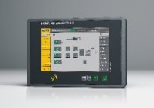

SAM 4.0: The Sigma Air Manager 4.0 (SAM 4.0) not only ensures highly efficient monitoring and control of all compressed air station components, it also enables them to take advantage of the future-oriented benefits that Industrie 4.0 has to offer.

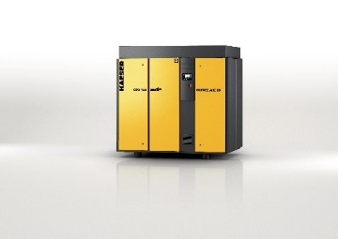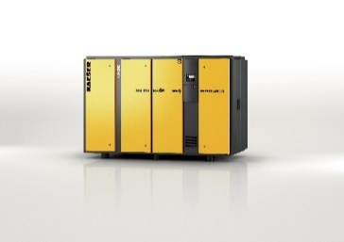

The CSG series (on the right with integrated i.HOC rotation dryer) delivers compressed air dependably and efficiently for oil-free applications.

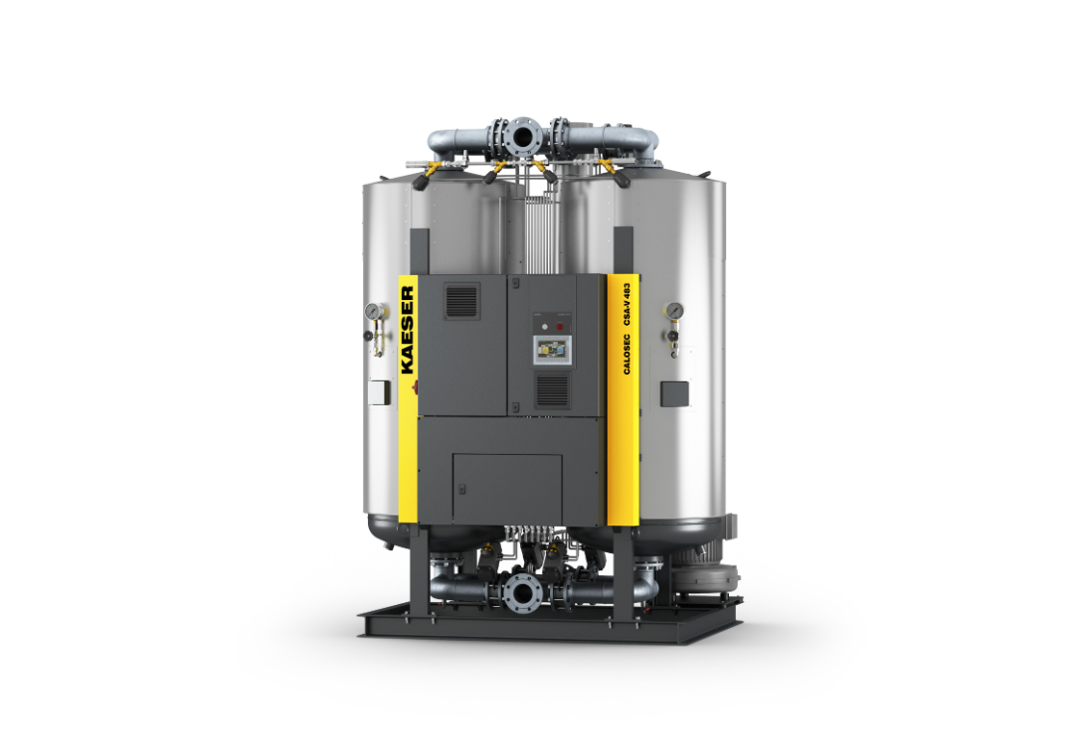
The heat-regenerated desiccant dryers Calosec are a particularly dependable
and energy-efficient solution for especially sensitive sectors such as the semiconductor industry.

