**Mobilair M44**

**Lightweight, quiet, economical**

**The Mobilair M44 compressor series from Kaeser Kompressoren bridges a market gap by offering portable compressed air systems that combine high performance with a compact, eco-friendly design.**

A new benchmark in portable compressed air technology: this innovative compressor system, powered by a Kubota diesel engine that meets Stage V emission standards, sets a new standard in portable compressed air technology. Positioned between Kaeser’s existing 3 m³ and 5 m³ units, it meets the European market's need for a powerful, compact, and environmentally friendly solution. With anti-frost control equipped as standard, it is particularly well-suited for operation of pneumatic hammers and impact moles. The Mobilair M44 also offers a choice of an 8.5 kVA or 13 kVA generator, providing both compressed air and electrical power, making it an indispensable energy source on the construction site.

The system is powered by a highly efficient Kubota diesel engine, complete with a diesel particulate filter. With optimised power management and a low maximum engine speed of 2500 rpm, this engine delivers outstanding fuel efficiency and minimal emissions. These qualities make the new compressor system an environmentally friendly option that meets strict emission regulations while also reducing operating costs.

Delivering an output of 4.1 m³/min at an operating pressure of 7 bar, and equipped with a rotary screw compressor featuring the Sigma Profile, this system ensures exceptional efficiency and reliability. The new "Sigma Control Smart" controller makes operation even easier. Maximum pressure can be adjusted precisely in 0.1-bar increments between 6 and 7.5 bar at the touch of a button – an ideal solution for compensation of pressure losses in long hose lines.

Additional system highlights include cost-effective operation and easy access to all maintenance points. Moreover, the use of a spin-on cartridge for highly-effective oil separation makes servicing simple and efficient. Another key benefit is the unit's lightweight design: even with the optional compressed air aftercooler, the Mobilair M44 weighs in at under 750 kg, allowing it to be towed on the road without a braked trailer.

Kaeser provides a range of optional features beyond the standard models, including compressed air reheating and filters for technically oil-free compressed air. These configurations come equipped with a braked chassis, and stationary versions are also available. For added flexibility, the PE wing doors can be customised with colours other than the standard yellow.

This new portable rotary screw compressor is a versatile, efficient, and eco-friendly product, perfect for both mobile and stationary applications.

Free for publication, Copy appreciated

|  |
| --- |
|  |

Images:

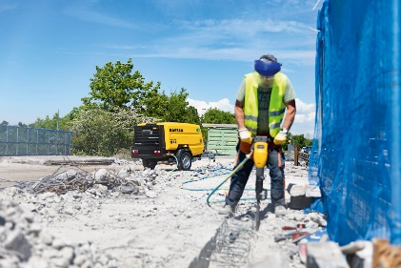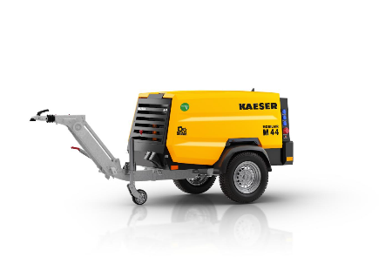

The Mobilair M44 is the efficient and cost-effective choice for a portable rotary screw compressor.