Kaeser Kompressoren at BrauBeviale in Nuremberg
Premium quality in a glass: Compressed air for the beverage industry
The beverage and brewing industry today faces a clear challenge: costs must be reduced without compromising on product quality. Since compressed air accounts for a significant portion of the industry’s energy requirement, high efficiency and reliability of supply are essential to cost-effective operation. This applies equally to small-scale craft breweries and large industrial bottling plants.
CSG series - a class above in performance and efficiency
When it comes to process reliability and energy efficiency, CSG series oil-free compression rotary screw compressors take the beverage production and bottling processes to the next level. Specially developed for the sensitive requirements of the brewing and beverage industry, these systems provide oil-free compressed air certified in accordance with ISO 8573-1, Class 0 for maximum product safety. What’s more, thanks to IE5 synchronous reluctance motors and the Sigma Profile, CSG compressors achieve significant energy savings. The water-cooled option with i.HOC dryer and heat recovery uses the compressor exhaust heat twice – achieving maximum cost-efficiency and process reliability.
Aircenter series - efficiency with minimal space requirement
The heart of our Aircenter SM 13 is a highly efficient, fluid-injecting rotary screw compressor. Combined with an energy-saving refrigeration dryer and mounted atop a compact air receiver, this turnkey complete compressed air station requires minimal space. Whether it’s for precision pneumatic handling, controlling sensitive valves, or providing continuous process air for bottle filling, the Aircenter delivers a constant and dependable compressed air supply. Among other things, this protects sensitive filling processes against downtime and ensures continuous, stable holding power during transportation of bottles and containers. The SM 13 model is also available with a frequency converter for infinitely variable flow rate control.
i.Comp 3 and i.Comp 8/9 series – durable, compact, needs-oriented
The i.Comp 8/9 impresses with its innovative drive concept: the robust PE enclosure conceals an oil-free reciprocating compressor powered by a variable-speed drive motor that always delivers the exact volume of compressed air required. With the i.Comp Tower T connection-ready complete system, the compressor, air receiver, refrigeration dryer and Sigma Control controller are all housed together on a compact footprint – perfect for operation in breweries and beverage producers.
As a portable solution, the i.Comp 3 delivers oil-free compressed air directly at the point of use and is therefore ideal for small-scale craft breweries or flexible service work.
Rotary lobe blower BBC - “Plug & Work”
Connection-ready Compact series blowers with the Omega Profile guarantee outstanding reliability and energy efficiency for raw materials conveying and aeration applications. Complete with the Sigma Control controller, all necessary sensors, a star-delta starter (or frequency converter), and full CE and EMC certification, they significantly reduce the time and costs associated with planning, installation, and process monitoring – ensuring long-lasting, trouble-free operation in breweries and bottling plants. Needless to say, these highly efficient rotary lobe blowers are also available as base-mounted units without a control cabinet.
Booster systems CN C SFC - perfect for PET
This complete system has it all: an updated design, featuring a footprint around half the size of the previous model, means that CN C series boosters look as good on the inside as they do on the outside. A new component layout not only ensures optimised cooling air flow, but also provides improved maintenance access. For precision adjustment to fluctuating compressed air requirements – such as when producing PET bottles of different sizes – Kaeser boosters are optionally available with frequency control. The Sigma Control controller with its assorted interfaces provides new, multiple monitoring and control options. Moreover, it is compatible with the Sigma Air Manager 4.0 compressed air management system and its integrated energy management software.
Kaeser Kompressoren will be showcasing at BrauBeviale in Hall 10, Stand 218, how a future-proof compressed air supply is generated and treated in compliance with the highest quality standards.
Free for publication, Copy appreciated

Images:
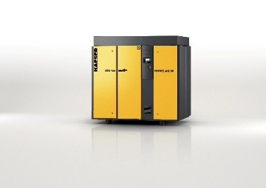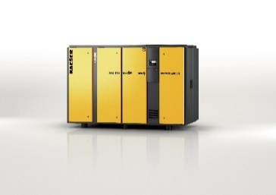

The CSG series (on the right with integrated i.HOC rotation dryer) delivers compressed air dependably and efficiently for oil-free applications.

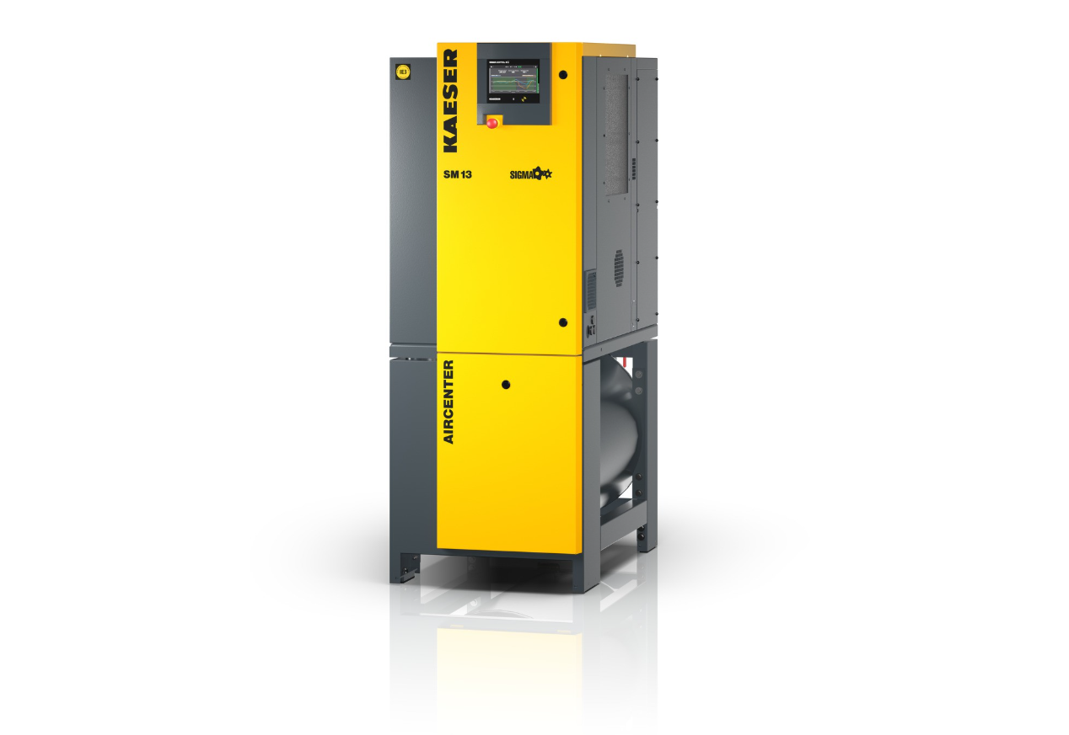
Covering flow rates from 0.26 to 2.7 m³/min, Kaeser’s Aircenter series models provide dependable and efficient compressed air production, treatment and storage within a single compact unit.
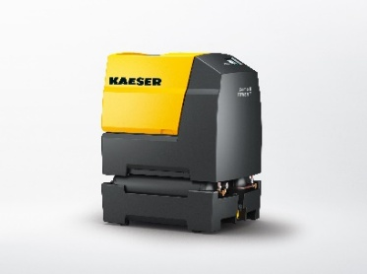

“Compressed air for the workshop”: The i.Comp 8/9 impresses with its innovative drive concept.

