e-power M10E and M13E portable compressors

Compact powerhouses

Powerful, lightweight, quiet, versatile, and easy to transport: these are the key features of the smallest models in the e-power portable compressor range, the Mobilair M10E and M13E. Together with the Purpac F16 support frame, which includes a compressed air aftercooler and filter combination for the 1m³ class, users can even take advantage of technically oil-free compressed air.

With an air delivery volume of 1.2 m³ per minute at 7 bar, the Mobilair M13E portable compressor is able to power pneumatic hammers, saws, sewer robots, or even impact moles. Moreover, pressure variants of 10-, 13-, and 15-bar are also available, which - depending on the pressure level - are perfect for applications ranging from traditional hammer operations, blasting work, and cable blowing, to even serving as a temporary replacement in compressor rooms.
Featuring a 7.5 kW motor, the manually-towable M13E rotary screw compressor simply plugs into a 400V CEE socket with a 32A pre-fuse and is ready for immediate operation. For installation sites with a limited power supply, whether that be due to the available socket, construction site power distributor, generator, or external battery storage for example, then the M10E with its 5.5 kW motor and slightly lower flow rate truly comes into its own. Here, a 16A connection is sufficient for operation, which significantly expands the range of potential use cases.

For construction sites without a power supply, then the petrol-powered M13 and M17 model variants are the ideal choice and naturally comply with Emission Stage V standards.

All models are equipped with a corrosion-resistant soundproof enclosure made from rotation-sintered polyethylene, making them exceptionally quiet and highly durable.

Since these compressors are so compact and lightweight, they can be easily transported in any delivery vehicle, or on the loading floor of a truck or pick-up, leaving the vehicle’s towing hitch free for other transportation uses.

In addition, the compressors can be equipped with an external compressed air aftercooler for certain applications that may require cool and condensate-free compressed air. The aftercooler is installed in a support frame equipped with fixed connections for compressed air, condensate return and electrical power (12 V supply from the compressor) to drive the aftercooler fan. Accumulating condensate is collected in a canister within the compressor, allowing for professional disposal. In the manually manoeuvrable sister models with petrol engine and identical design, the condensate is evaporated via the hot engine exhaust gases. The support frame in the Purpac A16 version includes a compressed air aftercooler, and as Purpac F16, it also includes a microfilter combination for technically oil-free compressed air.

The M10E and M13E are also especially user-friendly when it comes to maintenance and handling: manoeuvrability on the construction site is made simple thanks to the long handle, rugged wheels with pneumatic tyres, four convenient lifting-lugs and a counter-sunk crane eye. Last but not least, all maintenance points are easily accessible thanks to the wide-opening sound enclosure.

Released for publication, copy requested

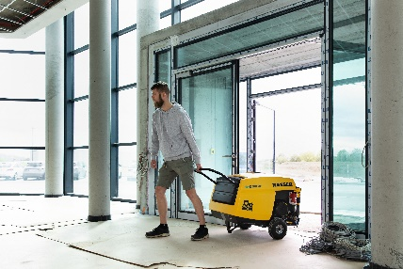

The powerful and quiet M13 portable compressor features an electric motor for maximum versatility. An alternative version with a petrol engine is also available.

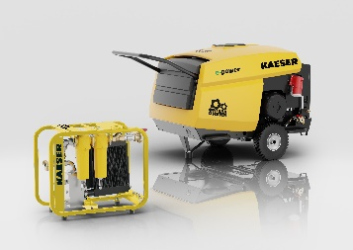

Practical support frame with compressed air aftercooler and microfilter combination for technically oil-free compressed air.

